SEC Form 3
FORM 3 | UNITED STATES SECURITIES AND EXCHANGE COMMISSION  Washington, D.C. 20549  INITIAL STATEMENT OF BENEFICIAL OWNERSHIP OF SECURITIES  Filed pursuant to Section 16(a) of the Securities Exchange Act of 1934  or Section 30(h) of the Investment Company Act of 1940
  OMB APPROVAL
  OMB Number: | 3235-0104
  Estimated average burden
  hours per response: | 0.5
1. Name and Address of Reporting Person*  (Street) | 2. Date of Event Requiring Statement (Month/Day/Year)  10/16/2026 | 3. Issuer Name and Ticker or Trading Symbol  Accel Entertainment, Inc. [ ACEL ]  Foreign Trading Symbol
  Arntzen Steven W.
  (Last) | (First) | (Middle)
  C/O ACCEL ENTERTAINMENT, INC.
  140 TOWER DRIVE
  BURR RIDGE | IL | 60527
  (City) | (State) | (Zip)
 |  | 4. Relationship of Reporting Person(s) to Issuer  (Check all applicable) | 5. If Amendment, Date of Original Filed (Month/Day/Year)
   | Director |  | 10% Owner
   | Officer (give title below) |  | Other (specify below)
  Chief Strategy Officer
6. Individual or Joint/Group Filing (Check Applicable Line)
Form filed by One Reporting Person
Form filed by More than One Reporting Person

Table I - Non-Derivative Securities Beneficially Owned
1. Title of Security (Instr. 4) | 2. Amount of Securities Beneficially Owned (Instr. 4) | 3. Ownership Form: Direct (D) or Indirect (I) (Instr. 5) | 4. Nature of Indirect Beneficial Ownership (Instr. 5)
Class A-1 Common Stock | 269,586 | D
Table II - Derivative Securities Beneficially Owned
(e.g., puts, calls, warrants, options, convertible securities)
1. Title of Derivative Security (Instr. 4) | 2. Date Exercisable and Expiration Date (Month/Day/Year) |  | 3. Title and Amount of Securities Underlying Derivative Security (Instr. 4) |  | 4. Conversion or Exercise Price of Derivative Security | 5. Ownership Form: Direct (D) or Indirect (I) (Instr. 5) | 6. Nature of Indirect Beneficial Ownership (Instr. 5)
1. Title of Derivative Security (Instr. 4) | Date Exercisable | Expiration Date | Title | Amount or Number of Shares | 4. Conversion or Exercise Price of Derivative Security | 5. Ownership Form: Direct (D) or Indirect (I) (Instr. 5) | 6. Nature of Indirect Beneficial Ownership (Instr. 5)
Restricted Stock Unit | 02/25/2027 | (1) | Class A-1 Common Stock | 19,281 | (2) | D
Explanation of Responses:
1. 100% of the RSUs will vest on February 25, 2027, subject to the Reporting Person's continued service to the Issuer on the vesting date.
2. Each restricted stock unit ("RSU") represents a contingent right to receive one share of the Issuer's Class A-1 common stock upon settlement for no consideration.
Remarks:
 | /s/ Derek Harmer, As Attorney-In-Fact for Steven Arntzen | 10/22/2026
 | ** Signature of Reporting Person | Date
Reminder: Report on a separate line for each class of securities beneficially owned directly or indirectly.
* If the form is filed by more than one reporting person, see Instruction 5 (b)(v).
** Intentional misstatements or omissions of facts constitute Federal Criminal Violations See 18 U.S.C. 1001 and 15 U.S.C. 78ff(a).
Note: File three copies of this Form, one of which must be manually signed. If space is insufficient, see Instruction 6 for procedure.
Persons who respond to the collection of information contained in this form are not required to respond unless the form displays a currently valid OMB Number.
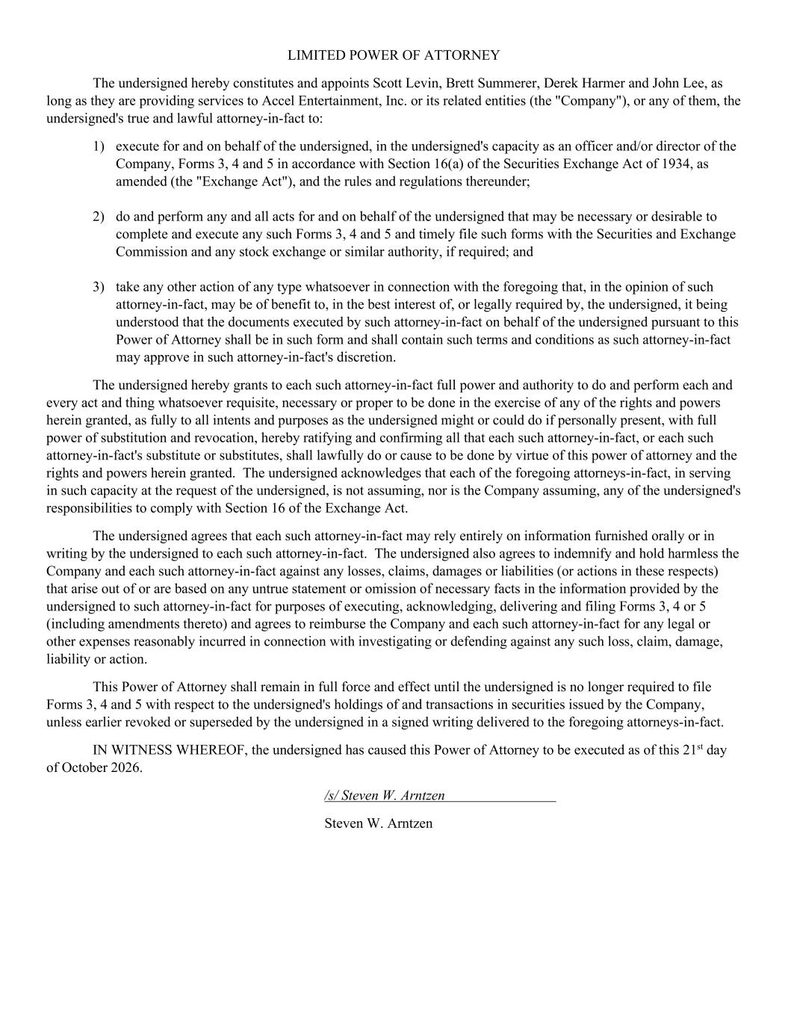
LIMITED POWER OF ATTORNEY The undersigned hereby constitutes and appoints Scott Levin, Brett Summerer, Derek Harmer and John Lee, as long as they are providing services to Accel Entertainment, Inc. or its related entities (the "Company"), or any of them, the undersigned's true and lawful attorney-in-fact to: 1) execute for and on behalf of the undersigned, in the undersigned's capacity as an officer and/or director of the Company, Forms 3, 4 and 5 in accordance with Section 16(a) of the Securities Exchange Act of 1934, as amended (the "Exchange Act"), and the rules and regulations thereunder; 2) do and perform any and all acts for and on behalf of the undersigned that may be necessary or desirable to complete and execute any such Forms 3, 4 and 5 and timely file such forms with the Securities and Exchange Commission and any stock exchange or similar authority, if required; and 3) take any other action of any type whatsoever in connection with the foregoing that, in the opinion of such attorney-in-fact, may be of benefit to, in the best interest of, or legally required by, the undersigned, it being understood that the documents executed by such attorney-in-fact on behalf of the undersigned pursuant to this Power of Attorney shall be in such form and shall contain such terms and conditions as such attorney-in-fact may approve in such attorney-in-fact's discretion. The undersigned hereby grants to each such attorney-in-fact full power and authority to do and perform each and every act and thing whatsoever requisite, necessary or proper to be done in the exercise of any of the rights and powers herein granted, as fully to all intents and purposes as the undersigned might or could do if personally present, with full power of substitution and revocation, hereby ratifying and confirming all that each such attorney-in-fact, or each such attorney-in-fact's substitute or substitutes, shall lawfully do or cause to be done by virtue of this power of attorney and the rights and powers herein granted. The undersigned acknowledges that each of the foregoing attorneys-in-fact, in serving in such capacity at the request of the undersigned, is not assuming, nor is the Company assuming, any of the undersigned's responsibilities to comply with Section 16 of the Exchange Act. The undersigned agrees that each such attorney-in-fact may rely entirely on information furnished orally or in writing by the undersigned to each such attorney-in-fact. The undersigned also agrees to indemnify and hold harmless the Company and each such attorney-in-fact against any losses, claims, damages or liabilities (or actions in these respects) that arise out of or are based on any untrue statement or omission of necessary facts in the information provided by the undersigned to such attorney-in-fact for purposes of executing, acknowledging, delivering and filing Forms 3, 4 or 5 (including amendments thereto) and agrees to reimburse the Company and each such attorney-in-fact for any legal or other expenses reasonably incurred in connection with investigating or defending against any such loss, claim, damage, liability or action. This Power of Attorney shall remain in full force and effect until the undersigned is no longer required to file Forms 3, 4 and 5 with respect to the undersigned's holdings of and transactions in securities issued by the Company, unless earlier revoked or superseded by the undersigned in a signed writing delivered to the foregoing attorneys-in-fact. IN WITNESS WHEREOF, the undersigned has caused this Power of Attorney to be executed as of this 21st day of October 2026. /s/ Steven W. Arntzen Steven W. Arntzen

